**Risk Escalation Guideline**

This Guidance note focuses on Risk escalation and its ownership transfer at the following levels:

1. Project to Country office
2. Country office to Regional Bureau
3. Regional Bureau to Risk Committee
4. Risk Committee to Executive Group

According to the ERM Policy, risks should as far as possible be handled by line management and treated by the Risk Owner or the person appointed by the Risk Owner. In some cases, however, circumstances pertaining to the treatment itself may exceed the authority/mandate of the Risk Owner. Risk should be escalated if the Head of Office/Risk owner considers that the risk meets one or more of the following criteria:

1. Treatment of the risk requires decisions/actions, e.g. expenditures, that are beyond what the risk owner is authorized to decide;
2. The risk cuts across, or may impact, multiple offices (e.g. it affects a number of Country Offices or the entire organization), and/or addressing the risk requires action by multiple offices; or
3. Addressing the risk requires corporate changes (e.g. changes to corporate policies); or;
4. Grievances from stakeholders have been received to which the risk owner cannot impartially and/or effectively respond.

When a risk is escalated, the Risk Owner must provide the receiving manager with complete information about the risk in order to enable the receiving manager to act appropriately. If and when escalation is urgent, it is acceptable to communicate escalation by phone or e-mail and update the risk register afterwards.

The risk ownership is transferred when a risk has been escalated and accepted. Therefore, the ownership of the risk is transferred to the receiving manager and becomes his/her responsibility to take action. However, it is important to note that the change of ownership will not take place until the receiving manager has confirmed that he/she accepts the ownership. A response to the request for risk transfer should be provided within 5 working days. The escalation of the risk and the change of ownership should be noted in the risk register.

If the receiving manager decides that the risk does not warrant escalation, it may be de-escalated (to the original risk owner or other suitable person). Any de-escalation of risks should be noted in the risk register along with the accompanying change of risk ownership.

It is important to note that risk escalation should follow the applicable organizational structure i.e. from project to country office to Bureau (central/regional) and ultimately to the corporate level. See Chart 1 and 2: Risk Escalation Structure and Process

**Chart 1: Risk Escalation Structure**

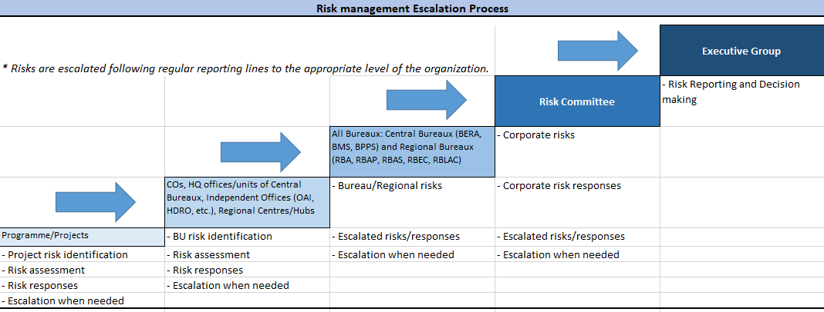

**Chart 2: Risk Escalation Process:**

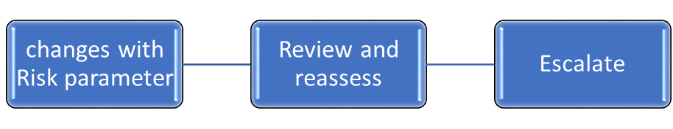

**\*Risk Owner (CO)**

RBx De-escalates Risk

CO Escalates Risk

**\* Regional Bureau**

Risk Committee De-escalates Risk

RB Escalates Risk

**Risk Committee**

* **Risk Escalation could be from Project to Country Office (CO), CO to Regional Bureau (RB), RB to Risk Committee, Risk Committee to Executive Group.**